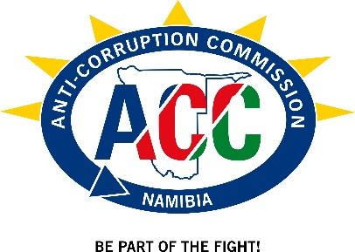
NATIONAL ANTI-CORRUPTION SONG COMPETITION- PARENTAL CONSENT FORM

I, _____________________________________________________________ (Parent’s/Guardian’s full name)

_____________________________________________________________________________ (Full Address)
________________________________________ (emergency phone number)
Parent/Guardian of ___________________________________________________________ (Child’s Name)
do hereby give my consent for my child to take part in the National Anti-Corruption Song Competition and to travel by bus/ road to and from event venue as part of the competition guidelines.
My child has the following allergies and/or special dietary requirements:
____________________________________________________________________________________________________________________________________________________________________________________(please give detailed information).
I hereby, on behalf of myself, my spouse, my executors and child, indemnify and absolve the Government of the Republic of Namibia, entities and all organisers,
Principal and any staff or authorised assistance of the school, including parents, against any or all claims of
whatsoever nature that may arise in connection with loss or damage to the property of my child or injury to the
person of my child in the course of the competition. The organizer and staff will, nevertheless, take all necessary
precautions for the safety and welfare of my child.

This is a legal document and no alterations will be accepted.
PLEASE NOTE THAT SHOULD YOU NOT SIGN AN INDEMNITY FORM; YOUR CHILD WILL NOT BE TAKEN ON FOR THE COMPETITION.
FORMS RECEIVED WITHOUT THE SIGNATURE OF A WITNESS WILL BE INVALID AND RETURNED TO
DISREGARDED.
SIGNATURE OF PARENT/GUARDIAN: _____________________________
SIGNATURE OF WITNESS: ________________________________________
DATE: ______________________ PLACE: ____________________________

